Research Style: IIE Transactions

Thesis Proposal
Evaluating and Enhancing Response to an Aerosolized Anthrax Attack in the Washington, DC Metropolitan Area

KYLE JAMOLIN, JONATHAN SALTZMAN, DARRELL SCHAEFER, SEBASTIAN SERRANO, AARON SHIM and JOSHUA SLOANE

Mentor: Dr. Jeffrey Herrmann - YES
Librarian: Jim Miller – YES

We pledge on our honor that we have not given or received any unauthorized assistance on this assignment.

Table of contents
- The Research Problem and Hypothesis ……………………………....3
- Literature Review …………………………………………………….5
  - Anthrax as a Bioweapon ……………………………………….5
  - Detection ……………………………………………………….5
  - Technological Surveillance …………………………………….6
  - Syndromic Surveillance ………………………………………..6
  - Additional Detection Methods …………………………………7
  - Response ……………………………………………………….8
  - Experimental/Analysis Studies …………………………………9
- Methodology ……………………………………………………..….10
  - Methodology Organization …………………………………....10
  - Steps of SSM ………………………………………………….11
  - Limitations …………………………………………………….16
- Conclusion …………………………………………………………..17
- Appendix …………………………………………………………….18
  - Cases of anthrax outbreaks…………………………………….18
  - Possible simulations and experiments …………………….......18
  - Budget …………………………………………………….......21
  - Timeline …………………………………………………....….21
  - IRB Application………………………………………………..22
  - IRB Questions…………………………………………………26
  - Acronyms ……………………………………………………..28
  - Glossary ……………………………………………………….29
  - References …………………………………………………….31

1. The Research Problem and Hypothesis

With the increase in awareness of terrorist attacks in the last decade, the threat of bioterrorism is increasingly troubling. The DC metropolitan area is vulnerable to an aerosolized anthrax attack because current governmental response plans are underdeveloped and inefficient. The fact that we are not anticipating such a rare attack has caused a sense of complacency and unpreparedness with the nation’s approach to structuring the responses. The processes of detecting the pathogen, coordinating among various governmental agencies and response teams during the investigation of an attack, determining a course of action, and executing a response are all tenuously linked at this point in time (Hupert et al., 2009). Various factors lead to the ambiguity occurring between the detection of the pathogen and the execution of a response, which occurs during the processes of inter-agency coordination (Presidential Directive, 2004) and determination of a course of action (Abbey, 2010). This ambiguity would increase the response time in the event of an aerosolized anthrax attack, leading to increased damage as a result of the attack.
Several field-specific terms will be frequently cited in this proposal and throughout our research. Figure 1 displays an explanation of time-related terms we have created and defined for purposes of this research study. We will refer to the point when the appropriate response has begun to be executed, whether that response is the distribution of medicine or the start of a cleanup, as the solution. The period of time from the execution of the attack until the solution is known as the response time. The period of time between the execution of the attack and the decision of how to respond to it is known as the Critical Analysis Period (CAP). This includes detection, investigation, and determining a course of acion. The length of time of the CAP is known as the Critical Analysis Delay (CAD). Within the CAD there is the detection delay, investigation delay, and the decision delay. The length of time following the CAP and before the solution is the response delay. Altogether, the response delay and the CAD make up the length of the response time (see Figure 1). A contact is anyone who has been in contact with aerosolized anthrax, although he or she may not be ill as a result of the contact. A casualty is any death occurring due to contact with anthrax.
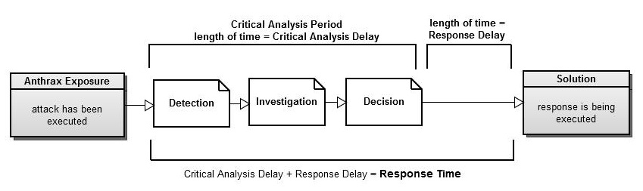Figure 1- Timeline of Anthrax Response
The research question that will guide this study is: What are the problems with the CAP after an aerosolized anthrax attack, and what framework can be developed and implemented to improve the systems involved in the response so as to reduce the CAD and thus the response time of parties? We define parties as the various governmental and health agencies, and other actors involved in the response of an attack. Our goal is to increase the preparedness of the DC metropolitan area for an aerosolized anthrax attack. We will begin with the acquisition of knowledge on the topic via soft operations research. We will investigate the factors that cause the ambiguity of the procedures that follow an aerosolized anthrax attack, and subsequently make recommendations relevant agencies such as the Centers for Disease Control and Prevention (CDC) and the Department of Homeland Security (DHS) to improve the system and thus decrease the response time following an attack.

2. Literature Review
Our literature review is currently giving us a background on matters regarding anthrax and the response to an anthrax attack.
2.1 Anthrax as a Bio-weapon
Since the highly publicized anthrax attacks of 2001, much attention and concern have been directed towards the possibility of a large-scale aerosol bioterrorism attack (Inglesby et al., 2002). Anthrax is odorless, and the spores are completely invisible to the human eye no matter how massive the release (Inglesby et al., 2002). The microscopic size of the spores (2 to 6 microns in diameter) allows the spores to be easily aerosolized and invade a human’s lower respiratory tissues. Anthrax spores are resistant to desiccation, ultraviolet light, heat, and various disinfectants (Cieslak and Eitzen, 1999).
Case studies have revealed anthrax to have an incubation period in exposed patients anywhere from 1 to 17 days (Doganay et al., 2010). This incubation period has such a wide range of time because anthrax-related symptoms can be mistaken for viral, bacterial, or fungal infections (Wyatt, 2002). The casualty rate is 95% if the patient is not treated within 48 hours after this period. Oral ciprofloxacin and doxycycline are the current antibiotics of choice (prophylaxis and treatment) and should be administered at the earliest possible stage of the disease (Cieslak and Eitzen, 1999). Thus, speed of detection and surveillance is paramount.
2.2 Detection
The means of detecting anthrax can be divided into two categories: technological and syndromic. Technological surveillance uses detection systems and central computers to identify bioterrorist attacks, whereas syndromic surveillance involves analysis of health patients’ symptoms by doctors and epidemiologists to determine if there is an event of bioterrorism. The United States government has developed methods for both forms of surveillance.
2.3 Technological Surveillance
The primary federal technological surveillance system, known as BioWatch, received initial funding in spring of 2003 (Fedorowicz and Gogan, 2009). BioWatch encompasses what we define as CAP (Shea and Lister 2003). The process starts with the airborne pathogen landing on filters mounted on Environmental Protection Agency (EPA) air quality monitoring stations. The filters are collected every twenty-four hours and analyzed at laboratories associated with the national Laboratory Response Network for Bioterrorism (LRN). The CDC oversees analysis, while local jurisdictions and the Federal Bureau of Investigation (FBI) determine the proper solution (Shea and Lister 2003). Early detection and a short CAP allows for an early warning, in which simple protocols such as closing windows and remaining relatively inactive can prevent exposure to a large-scale attack (Wyatt, 2002). The Biological Aerosol Sentry and Information System (BASIS) uses the same concept of filters that automatically rotate on an hourly basis, and the used filters are manually removed for testing (Shea and Lister 2003). Additionally, BioWatch’s sensitivity must be taken into account, as some pathogens are normal for the background levels of select portions of the United States.
2.4 Syndromic Surveillance
Syndromic surveillance detects bioterrorist attacks and natural disease outbreaks through the local and state health departments’ analysis of hospital reports and pharmaceutical purchases. The CAP starts on the local department level and if symptom patterns occur among different communities, the state health department investigates on a broader scale. The system of the “observant doctor” takes effect when a patient exhibits odd symptoms or the doctor notices an unusual spike in a certain symptom. Physicians or school nurses can alert the CDC within a day (Abbey, 2010). Epidemiologists analyze the incoming cases and look for patterns. Over the course of anthrax’s varying incubation period (ranging from 1 day to 17 days), the health department can conclude whether or not an attack has occurred.
On a federal level, BioSense integrates the Department of Defense (DoD), Veterans Affairs facilities, and hospitals throughout multiple states (10 as of 2008) to quickly and accurately identify a bioterrorist attack (Fedorowicz and Gogan, 2009). The program has since changed to detect natural outbreaks of diseases.
2.5 Additional Detection Methods
The Electronic Surveillance System for the Early Notification of Community-based Epidemics (ESSENCE) also facilitates the detection of anthrax. The system is used throughout the country and compares the international classification of diseases, pharmaceutical sales, emergency room chief complaints (primary symptoms), and demographics to determine earlier detection (Foster, 2004).
Clinical testing and diagnosis is another mechanism at the forefront of post-exposure detection of a biological outbreak attack. The problem with these methods lies within the delay for the cultures to incubate or the assays to completely process which can take up to 2 days (Rao et al., 2010). Moreover, syndromic surveillance is not a reliable means of early detection. A study shows that when presented with information outlining early B. anthracis symptoms, most physicians misdiagnosed the disease as pneumonia and influenza and only a few reported that they would order blood cultures which would imminently lead to the correct diagnosis (Stephens and Marvin, 2010).

2.6 Response
The protocols for handling a bioterrorist attack range from federal policies to practical individual actions. On the federal level, in addition to programs such as BioWatch and BioSense, the government has a set of procedures for handling bioterrorism.
Detection technologies and decontamination methods require constant updating. The early-warning system must track the dynamics of the aerosol cloud, classify initial agents, and provide a time frame for protective action (Wyatt, 2002). Analysis extends to finding the perpetrator, and the response involves coordinating between the National Response Plan and local and state plans (Presidential Directive, 2004). The DHS would oversee transportation and law enforcement while the Department of Health and Human Services (HHS) would run the response, and both departments would work alongside with the EPA, Attorney General, and the Secretaries of Defense, Agriculture, and Labor to devise the best plan for decontamination (Presidential Directive, 2004).
The Strategic National Stockpile (SNS) contains prophylaxis/medical supplies with the purpose of being distributed in times of public health emergencies on a massive scale. State and federal officials agree that when an emergency response is required, medicines will be dispensed within 12 hours (CDC, 2008). The CRI encourages a 48 hour deadline to establish points of dispensing at 72 CRI cities distribute prophylaxis antibiotics and counter-measures throughout the country, with the prophylaxis supplies coming from the SNS (Hupert et al., 2009 and Prevention, 2010).
The Kansas Department of Health and Environment (KDHE, 2010) has established a set of guidelines for investigating bioterrorism that can be used regardless of geographic location. The document stresses the need for an educated public in order to curtail the CAP and initiate the solution. The document also lists a set of protocols for the general public and officials to investigate anthrax, which include diagnosing the disease, finding the source, identifying additional cases, determining public health concern, controlling/preventing further outbreak, communicating, and educating as well as distributing a number of prescriptions and vaccinations. The plan also stresses the need for interoperable (relating formerly independent applications) communication between emergency personnel, police, National Guard, media, political leaders, and the general public (KDHE, 2010). Plans on several levels of government suggest a similar need for coordination.
2.7 Experimental/Analysis Studies
A study by Research and Development (RAND) Defense Institute investigated and analyzed the performance of the Department of Defense (DoD) in responding to three anthrax related incidents (Kelly et al., 2006). Using documents and interviews, the study thoroughly scrutinized what occurs, how things should actually occur, and recommendations for improvement. The results revealed uncertainty, poor communication and coordination, and noncompliance with the framework guidelines of the National Incident Management System (NIMS). The research’s methodological approach is similar to BIOCOUNTER’s in analyzing and acting upon the current system in place for surveillance and response (Kelly et al., 2006).
A quantitative analysis also exists for the CRI where a time-transition model was utilized to describe the dynamic interaction between the progression of B. anthracis symptoms and the rate of dispensing and utilizing prophylaxis under CRI guidelines (CDC 2004). Using a multitude of parameters, the model produced detrimental results for the hypothetical post exposed population if the CRI campaign is delayed or not coordinated properly (Hupert et al., 2009). Similar to Hupert and Kelly’s studies, we will also be creating simulations based on hypothetical attacks. These will be based on metropolitan D.C., and the coordination and execution of the response will be done in accordance with information gathered from documents and interviews.
3. Methodology
3.1 Methodology Organization
Soft Systems Methodology (SSM) is the most effective methodology to address our research question. Researchers use this methodology to describe and understand complex issues, specifically those that arise along systems that involve multiple human parties. These parties hold multiple perspectives of various issues relating to the system, and have several problems regarding the multiple interactions throughout the system. This is true for the case of counter-terrorist methods. There will be a different method of defense for each organization (although they may resemble one another) that can cause confusion amongst the interaction. Mingers (2009) states that SSM addresses issues that require improvement, or “messes”, rather than traditional scientific inquiries that usually require a simpler solution and heavily rely on mathematical calculations.
SSM consists of seven steps, as Figure 2 demonstrates: (1) describing the problem situation, focusing on its history and scope, (2) forming a rich picture (Checkland, 2000) of the issue at hand, and understanding how parties perceive other parties, (3) establishing the root definition, or the brief description of the system in which it includes what, why, and how the system operates (Checkland, 2000), (4) developing models of interactions between the multiple parties involved in the process, (5) using the models as a guide to relate the rich picture to the root definitions, and clarify discrepancies in the system, (6) determining what changes will be feasible and desirable, and (7) reaching an agreement with all parties to adopt new procedures to improve the issue (Bentley 1993).
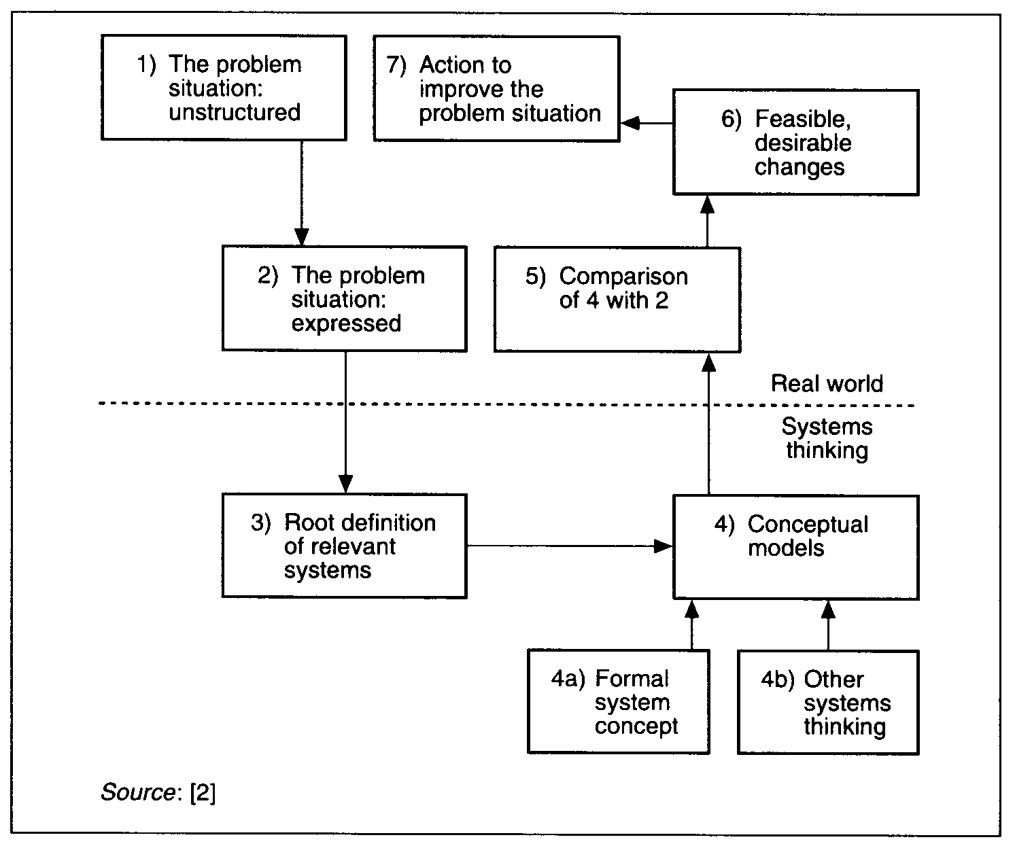
Figure 2- The Soft Systems Methodology of P.B. Checkland (Ho, 1994)
3.2 Steps of SSM
(1) Description of the Problem/Situation
We are addressing a mess, as research so far has indicated that there are indeed issues between parties (Morhaim, 2010), and there are multiple adjustments that could potentially be made to improve response time and coordination.
Team BIOCOUNTER will be addressing what has been identified as the inefficiency of ready emergency response during an aerosolized anthrax attack (Hupert et al., 2009), with a lack of a clear chain of command (Abbey, 2010) and poor coordination (Presidential Directive, 2004), that could slow response time and place people at higher risk in the event of an attack.
(2) Rich Pictures
After gathering enough information about the problem at hand, we will address our research’s rich pictures, the visual diagrams portraying operational definitions, and how they interact with each other. This will specifically show how the parties are related to each other. An example of one rich picture could be to depict visually what organizations are responsible for the different components of BioWatch. The main goal of developing rich pictures is to help better understand the problem described in Part 1.
During our research for the rich pictures, the mnemonic CATWOE is used. The Clients are the people who benefit directly from the system. In our case, this is the population of DC. The Actors are the parties in charge of carrying out the system. We will recruit and interview experts from the aforementioned government agencies, health departments, and University professors. These interviews will be conducted according to IRB standards and in a semi-structured format (sample in Appendix). Experts of interest include Dr. David Mosser (cell biology and molecular genetics), Professors Dorothy Beckett (biochemistry), Sam W. Joseph (cell biology), and Steven L. Salzburg (computer science.) The Transformations are the actions that actors carry out to fulfill the purpose of the root definition. See Figure 3 for a preliminary analysis of the actions that will take place in response to an anthrax attack. The Worldview is the point of view of each actor, as well as the system as a whole. If different actors have different motivations, then it will cause discrepancies in their responses. The Owner is defined as the party who has ultimate control of the system. It is our job to determine the proper owner. Finally, the Environment is the political, economic, and geographic background where the system occurs (Checkland, 2000). This has been partly identified as Washington, DC as well as surrounding jurisdictions. Additionally we plan to attend conferences that gather experts in various fields related to our topic, such as the National Urban Areas Security Initiative (UASI) Homeland Security Conference in San Francisco, CA, and the Aerobiology in Biodefense IV located in Glen Allen, VA.
(3) Root Definitions
The root definition that we will be analyzing is the system of identifying and responding to an aerosolized anthrax attack in Washington, DC. The major goal of this is to minimize the number of contacts and casualties due to the attack. To define the parties in the response, we will explore the aforementioned government documents. We must understand the official roles of parties during an attack, including what the parties should be doing, what or who they should be watching, and where they should be at any given time. We must be as familiar with the organizational structure as possible so we can compare these expectations to the reality of the system, gaining a better understanding of the failures of the system.
(4) Models of Interaction
Models of interaction display how the parties would respond and interact with each other during the anthrax response if every procedure were followed ideally. We will develop several models of interaction to accommodate two varying aspects: different jurisdictions in the metropolitan Washington area and the multiple perspectives from the aforementioned experts. Our models will present both sequential and concurrent events with their respective time constraints along with the parties involved with each event. An example of this lies in our preliminary model of interaction (see Figure 3), in which time constraints are depicted along with involved agencies and processes. The models we form will be more in-depth than the preliminary model, and the varying models will emphasize the differences of how each party reacts. When we have these models outlined, we will specify on the model where there needs to exist another interaction for purposes of expediting decision-making or if there are any discrepancies that may be detrimental or ambiguous to the entire CAP. We will base our models primarily on the root definitions, displaying the establishments with their interactions that should be in place in the event of an anthrax attack.
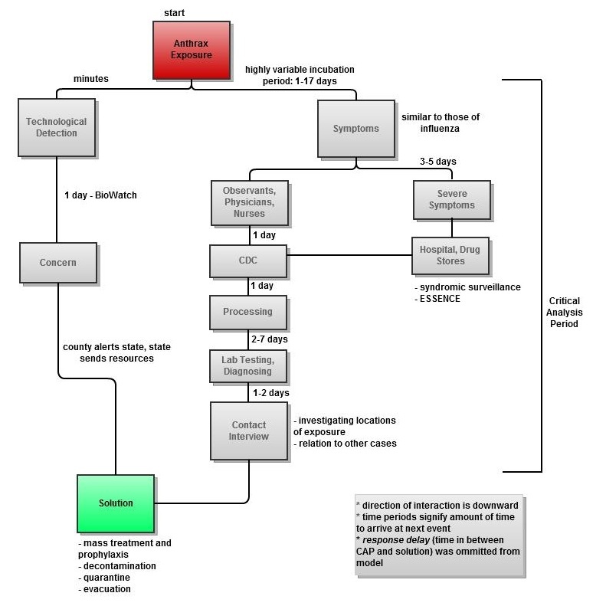
Figure 3- Preliminary Model of Interaction
(5) Comparison
Our goal is to develop one elaborate model that will show the progression of action. When our model is complete, we can determine through our judgment and the judgment of experts where there are discrepancies between the realistic rich pictures and the ideal models of interaction. We are seeking different viewpoints from experts of varying fields, which will facilitate the generation of ideas and identification of problems in the relationships between parties. The model will serve as a guide, as it will display a combination of both the rich picture and the models of interaction, and show the progression of responses following an attack.
(6) Feasible and Desirable
At this stage, we will look at possible methods to improve efficiency in the response to an anthrax attack. Until we complete the previous steps in our methodology, we will not know exactly what recommendations we will consider and how we want to test them. Therefore, the experiments listed below are meant to serve as examples of experiments that we could do, as opposed to what we are certain we will do.
Most likely, we will use more traditional methodological procedures, including experimental research, and mathematical models to test our ideas. We could potentially run computer simulations that model the interactions of the parties, as developed in Part 4. With this type of simulation, our recommendations such as improving communication between different organizations can be tested. This can be done using computer simulation programs such as Arena. They must decrease the projected response time after the outbreak. The major methods of decreasing response time are by reducing the amount of time between each step in the models of interaction, having multiple steps occur at the same time, and eliminating steps. For example, one hypothesis is if there were one database established that all of the different parties were able to access and edit, then information would be shared more rapidly. In addition, different parties would not need to interview the same contacts, which would reduce the number of steps each party would need to take. These are still possibilities since at our current stage of our methodology, it would be inappropriate to commit to any specific program. We are considering several other simulations and models which are described in appendix 6.2.
(7) Recommendation
Our final stage will be recommending our tested improvements to governmental agencies. As previously stated, some anticipated recommendations include implementing more sensors capable of rapidly detecting anthrax and developing a database for all of the parties to use during the CAP. The specific anticipated results of the paper are the hypotheses for the different experiments and models in Part 6, and these hypotheses will not be formalized until then. Assuming our recommendations are feasible and desirable, they would ideally result in a compromise among parties and adoption of new policies. Even if no policies are developed directly from our recommendations, they will still be useful by beginning a dialogue between the different organizations. In addition to improving Washington, DC’s response to an anthrax attack, we intend to present our findings at conferences such as the Public Health Preparedness Summit, as well as publish our results in a peer-reviewed journal. Our research will develop a useful methodology that could potentially be applied to independent studies of other cities as well.
3.3 Limitations
In dealing with government documents, there is always the problem of clearance and confidentiality. Although this is necessary for national security, it is a major block in gaining a fuller understanding of how the current system works. An example of this is the classification of the BioWatch program since, as mentioned previously, details such as the location and number of sensors are not made public.
Our potential simulations may not be able to cover all the factors of a bioterrorist attack. The different aspects of an aerosolized anthrax attack include weather patterns, human movement, and the actual locations of detectors, as mentioned previously in Part 6 of the methodology. Since our simulations must be simplified for ease of understanding, they may not fully assess an actual attack. Additionally, these factors are also confounding variables, especially natural factors which change erratically.
SSM is a process that is effective but can be arbitrary because the amount of time spent on each step is not predetermined. To proceed sequentially with SSM and to outline what we will be doing subsequent to each step, a thorough but arbitrary amount of time must be dedicated to discovering the required information.
4. Conclusion
In the modern age the nation is all too likely to become victim to a terrorist attack. A future attack may be done in the form of bioterrorism, specifically with aerosolized anthrax. Fortunately, the United States has not fallen victim to a devastating anthrax attack; however, the lack of a history with anthrax as a bio-weapon creates a sense of complacency and apathy that the event will ever occur and thus it is evident that we are unprepared. It only takes one attack to have a permanently disastrous impact on the country as a whole and by then it could be too late. Something as devastating as a successful bio-weapon attack, unfortunately, does not allow for second chances.
Our research’s aim is to prevent such an outcome in the case of an aerosolized anthrax bioterrorist attack. We plan to research the current situation and make recommendations to parties on courses of action they should take to be better prepared. Our chosen methodology, SSM, allows us to understand the plans of the numerous groups that have some form of defense in the metropolitan DC area, such as the DoD. Through SSM we can create rich pictures and models of interaction which show the interconnections between all the parties, and from that research we can form new models to create a more efficient response. This allows us to make recommendations to the parties involved in an effort to prevent contacts and casualties should an actual anthrax attack occur. It would be wise to be well-prepared for such an event, and the goal of our research is to make sure we are.
5. Appendix
5.1 Cases of anthrax outbreaks
Proof of the lethality lies in the 1979 incident in Sverdlovsk where an accidental outbreak at a Soviet military compound occurred and resulted in at least 66 deaths (Meselson et al., 1994).
5.2 Possible simulations and experiments
(1) Plume Model for a Metropolitan-Scale Attack
One possible test that we could create factors in wind, population, and commuting patterns. For our computer simulation, we will create a simplified model of the DC metropolitan area. The independent parameters in this simulation are the location where the anthrax is released, the amount of anthrax released, the atmospheric conditions (specifically the velocity of the wind), the number of sensors capable of detecting anthrax, and the location of these sensors in the area. Our process of choosing independent parameters will be based on a similar study that analyzes the ability of syndromic data to detect anthrax (Kong, Wallstrom and Hogan 2008). The atmospheric data we will use is from local airports. Like the previous study, we will look at two different amounts of anthrax: 0.1 and 0.5kg, and run 50 simulations for each amount. The location of the release of the anthrax will be randomized, but weighed to occur more frequently in more densely populated areas where the damage would be more severe. The dates and times will be selected uniformly over 2008 to 2009, and will include various hours in the day.
In this simulation, the anthrax will disperse, and if there is a high enough concentration of anthrax at the location of one of the sensors, the sensor will detect the pathogen. The concentration needed to set off a sensor is the threshold concentration and will be dependent on the sensor under study, as determined from the literature review. Our assumption is that the chance of detecting anthrax in the atmosphere will increase with a higher number of anthrax detectors. In addition, we hope to determine how many sensors are needed to have a high chance of detecting an anthrax attack, if it is reasonable to have this many sensors in a city based on the cost of owning and operating each sensor. Furthermore, results of this test would be applicable to any city that is a similar size with similar weather patterns.
(2) Mathematical Model for a Building-Scale Attack
We are considering developing a mathematical model for building-scale aerosolized anthrax attacks. In essence, this will determine the chance that we could correctly predict where terrorists will target. To do this analysis, we will look at many buildings within the metropolitan DC area. Based on a historical review on terrorist attacks, we will assign each building a percentage, signifying the percent chance that if an anthrax attack occurred in Washington, DC. The scope of this historical review has not yet been determined. Ideally, there is enough information on biological attacks in the United States to come up with reasonable estimates for the percentages. Most likely, hospitals, schools, stadiums, and other key buildings will be assigned individual numbers, and all other buildings that were not looked at specifically will be grouped together into one large group.
For a preliminary calculation, the total chance of detecting an attack in a building will be the sum of the percentages assigned to each building that is equipped with the tools to guarantee they would find anthrax in the building if attacked. From this model, we can determine how many of the high-target buildings must be capable of detecting anthrax to have a high chance of detecting a building-wide attack. This will also help determine if installing anthrax sensors in individual buildings is a feasible approach for detecting anthrax. If we decide to perform a more complex analysis, it will include the chance that the anthrax detectors will function in different sized buildings with varying HVAC layouts, and with different amounts of anthrax. For this, we will classify different buildings into different generic HVAC layouts, instead of performing a more complex analysis of each individual building. The effects of changing these parameters will be based on current literature, and will require simplification of conditions of the buildings (Hawkins, Hofacre, Wood and Sparks 2008). Based on the previously determined percentages, each building will be assigned a second value of the percent chance of detecting anthrax if there is an attack on that building. From that point, we could make a more useful calculation of how many buildings need anthrax detectors in order to have a high chance of detecting an attack. Although we may not be able to find an exact number of sensors or locations in the area established by BioWatch, we hope to obtain an approximate number for comparison. Even if we cannot obtain this information, our results will still be able to determine if a layout of sensors is feasible.
Although the metropolitan DC area is being examined, this is meant to be a rough approximation of a model area, so determining specifics about accurate HVAC layouts or exact percentages is not very important for future studies. This makes the results of this model less applicable to Washington, DC specifically and more applicable to any city that is a similar size with a similar number of target buildings. The method of choosing HVAC layouts has not yet been established. Since the model is meant to be a simplification, the layouts might be determined approximately based exclusively on the size of the building. If this does not appear to be sufficient, then available blueprints and HVAC layouts of similar types of buildings will be used. If this information is not readily available online, we will try to obtain this information on several types of buildings from our contacts. This model has a lot of flexibility so it can be adjusted easily based on the amount of time and feasibility of each component. The more in depth the analysis is, the more information it will provide, but it will also take more time.

5.3 Budget
- Additional Publication Subscriptions $150
- Conference Costs (four total, two members attending each)
  - Transportation $2050
  - Hotel/Accommodations $2050
  - Attendance $3300
  - Books/Publications $400
- Transportation Money to Governmental and Emergency Facilities $200

Total Cost: $8150
- Currently seeking grants opportunities through the Robert Woods Johnson Foundation and the ACCIAC Fellows Program

5.4 Timeline

Fall 2010:
- Complete methodology and preliminary thesis

Spring 2011:
- Present final thesis proposal to committee after having it reviewed by librarian
- Finalize questions to ask and conclude what information is required from experts
- Submit IRB approval
- Design team website
- Determine additional journal subscriptions we needed, conferences to attend, and possible need for additional funding

Fall 2011:
- Outline our final thesis
- Attend appropriate conferences
- Apply for grants if needed
- Begin simulation studies
- Conduct interviews

Spring 2012:
- Write out first three chapters of thesis
- Continue and finalize simulations
- Finalize interviews

Fall 2012:
- Continue to work on thesis
- Finalize list of experts for thesis conference and submit list to Gemstone

Spring 2013
- Finalize thesis
- Attend thesis conference

5.5 IRB Application

UNIVERSITY OF MARYLAND COLLEGE PARK
Institutional Review Board
Determination of Human Subject Research

Principal Investigator  [Must be Faculty/Staff] | Dr. Jeffrey W. Herrmann | Email Address | Jwh2@umd.edu
Address | 0151B Martin Hall | Telephone Number | (301) 405-5433

Student/Co-Investigators | Kyle Jamolin  Jonathan Saltzman  Darrell Schaefer  Sebastian Serrano  Joshua Sloane  Aaron Shim | Email Address(es) | kamisuke@aim.com  jonnsaltzman@gmail.com  Darrell.schaefer3@gmail.com  sebastiangserrano@gmail.com  joshuabsloane@gmail.com  Aarons016@gmail.com
Address | 9704 Dubarry Street  Glenn Dale, MD 20769 | Telephone Number(s) | (240) 899-3418  (410) 913-8369  (301) 518-8218  (978) 821-7927  (410) 227-6325  (240) 315-6030

Project Title | Bioweapon Inhibition Operating Containment Unit for the Negation of Terrorist Entities and Radicals (BIOCOUNTER)
Department | Gemstone Program
ORAA Proposal # | N/A

1) Project Information:
  - Provide a brief description of the project – Describe the specific objectives, including background information and rationale for the proposed project. This summary should be written in a way that will be intelligible to non-specialists in your specific subject area.
We are proposing a study that will evaluate and make recommendations to improve the system for responding to an aerosolized anthrax attack in the DC metropolitan area. We will focus on reducing response time by aiming to decrease the delay of time spent coordinating governmental and health agencies and forming a solution. Once we have finalized identifying specific issues regarding the response that could be improved upon, such as developing clear chains of command, we will attempt to improve the system model of the inter-agency response, and test it using plume modeling and computer simulations.

  - Describe the subject population/type of data/specimens to be studied – Identify who your subjects will be and indicate the type of data or specimens you will collect. Describe the methods in which the data or specimens will be collected, stored, and how confidentiality will be maintained.
We plan to conduct information-gathering interviews with university professors who have published articles relevant to bioterrorism, government officials who actively participate in counterterrorism efforts, and professionals located at health centers within the DC metropolitan area. We will contact these individuals through email and/or phone. We want to meet with subject matter experts that have either published scholarly articles related to bioterrorism or have a profession that addresses the issue of bioterrorism. Since the emphasis of the research is on making recommendations about the current response to an anthrax attack, we need to talk to people knowledgeable of the process to determine which recommendations need to be made. We will ask these experts to provide information about the plans of government agencies; we are not collecting private information.

Each expert will be interviewed separately. While we prefer to have interviews in person with each expert, we will offer him or her the choice of an interview in-person or via conference call. Each interview will last approximately one (1) hour. All interviews will discuss the plans of govern,ent agencies. We plan on speaking to each individual one (1) time. If, after analysis of the information resulting from an interview we want to conduct a second interview with an individual to clarify information provided previously, we will again ask for consent and inform the expert of the specific information we would like to gather.

We will take handwritten notes and use a tape recorder for an audio recording of in-person interviews. Data will then be transcribed onto two (2) USB flash drives (both stored together). The second flash drive will serve strictly as a back up. Cassette tapes with recorded audio will be kept on record. During the interviews, each interviewee will be identified by name, organization, and position within that organization. The USB flash drives and cassette tapes will remain stored in Dr. Jeffrey W. Herrmann’s office for confidentiality. The original handwritten notes will be stored with the cassette tapes. We are intending to keep the USB files and tape recording for the possibility of our own future research. Only the members of this research team will have access to the files and recordings.

2. Determination of Research:
45 CFR 46.102 (d): Research means a systematic investigation, including research development, testing and evaluation, designed to develop or contribute to generalizable knowledge. Activities which meet this definition constitute research for purposes of this policy, whether or not they are conducted or supported under a program which is considered research for other purposes. For example, some demonstration and service programs may include research activities.

- For existing specimens, was the data/specimen(s) obtained in a systematic manner?
⁯ Yes ⁯

- For future data collection, will the data/specimen(s) be obtained in a systematic manner?
Yes - research will be conducted through information-gathering interviews with a basic formula

- Is the project designed to develop or contribute to generalizable knowledge (publication, presentation, etc.)?
Yes

- Is the intent of the project to create an archive for the purpose of providing a resource for others to do research?
Yes

- For research only involving coded private information or specimens, was the private information or specimens collected specifically for the currently proposed research project through an interaction or intervention with living individuals?
Not Applicable - research does not only involve coded private information or specimens

3. Determination of Human Subject:
45 CFR 46.102(f): Human subject means a living individual about whom an investigator (whether professional or student) conducting research obtains (1) Data through intervention or interaction with the individual, or (2) Identifiable private information.

Intervention includes both physical procedures by which data are gathered and manipulations of the subject or the subject's environment that are performed for research purposes.

Interaction includes communication or interpersonal contact between investigator and subject.

Private information includes information about behavior that occurs in a context in which an individual can reasonably expect that no observation or recording is taking place, and information which has been provided for specific purposes by an individual and which the individual can reasonably expect will not be made public (for example, a medical record). Private information must be individually identifiable (i.e., the identity of the subject is or may readily be ascertained by the investigator or associated with the information) in order for obtaining the information to constitute research involving human subjects.

A. Does the study involve intervention or interaction with a human subject?
No: The study will not obtain data about living individuals.

B. Does the study involve access to identifiable private information?
No

C. Are data/specimens received by the investigator with identifiable private information?
⁯ No

D. Are the data/specimens coded such that a link exists that could allow the data/specimen(s) to be re-identified?
⁯ No

If Yes: Is there a written agreement that prohibits the Principal Investigator, Co Investigator, student investigator(s), and any other members of the research team from access to the link?
⁯ No ⁭ Yes

Are there other legal requirements that prohibit the release of the key to the investigators, until the subjects are deceased?
⁯ No ⁭ Yes (If Yes, please explain on a separate sheet of paper.)

4. Signatures:

_______________________________________ _______________________
Principal Investigator Date

_______________________________________
Print Name

_______________________________________ _______________________
Student Investigator Date

_______________________________________
Print Name

5.6 IRB Questions
Basic Questions
- What is your name?
- What is your current job?
- How much time have you spent in your most recent position?
- What is your official duty in your position?
- What do you do on a day to day basis for your position?
- Are there any discrepancies between what you are expected to do based on your job description compared with what you do on a regular basis?

Perceptions
- We have developed models of interaction showing how different federal, state, and local parties interact. What are your thoughts on our models of interaction?
- Kathleen Sebelius stated that the H1N1 crisis "confirmed that our public health response is only as strong as its weakest link." What do you feel is the weakest link in the detection, investigation, and decision-making process for an aerosolized anthrax attack??
- What needs to be changed or improved in the response to a terrorist attack, and are there any barriers that would interfere with the response?
- What are some warning signals that you interpret as indications of the need to initiate preparation procedures?

Personal Experience
- Do you have any insights based on your [work, research] experience that can be helpful in responding to a bioterrorist attack?
- What did you learn about the ability of (your agency/other agencies/your area of concentration) from the H1N1 crisis?
- What other experiences taught you about the ability of (your agency/other agencies/your area of concentration) to act successfully in a time of crisis?

Role in Response
- Describe your role in a response to an emergency such as a bioterrorism attack [if applicable].
- How does your role change when an incident command structure becomes operational?
- How does your agency/organization utilize and access the Strategic National Stockpile for the purposes of response?

Inter-agency Relations and Communications
- How would you be notified if another agency or party suspects that a bioterrorist attack may have occurred?
- How would you and your organization communicate with other parties during the response to an attack?
- How could communication be improved?
- How are the various parties involved in response interacting to improve awareness?
- Regarding a chain of command, what agency takes the lead in different aspects of the surveillance and response and where does your agency specifically take part?
- What other [agencies/parties] do you regularly work with and how have they performed in the past?
- Have you run any simulations or exercises pertaining to response? Have any of them been run with other agencies?
- The Department of Homeland Security acknowledges that there are independent security systems for plant, animal, and environmental protection. Do you believe that such security systems should be organized together as one or should they be independent of one another? Do you have comments regarding any interdependence between agencies involved in detecting, investigating, and responding to bioterrorism?
- How do we involve more hospitals and doctors in the process of syndromic surveillance, especially in reporting findings?

Current Projects and Innovations
- [If applicable] What academic research have you worked on in regards to [biological agents/threat detection/disease prevention]?
- How can your research be used to improve the response to an aerosolized anthrax attack?
- Are there any new details that you can disclose about BioWatch regarding new technologies and processes that government agencies are testing, and why would these specific improvements make technological surveillance and investigation more effective?
- What are your thoughts regarding the proposal to expand BioWatch to indoor areas? Is this economically feasible? Is BioWatch a suitable technological surveillance system for indoor areas, or should an independent system be integrated into the overall surveillance effort?
- Some research involving surveillance focuses specifically on technology such as BioWatch. Additional research emphasizes syndromic surveillance such as BioSense. Do you believe that programs such as BioWatch and BioSense should be combined as one dynamic surveillance system? Why or why not?
- How adaptable do you believe [your agency/other agencies/various actors] is/are to different scenarios and situations?
- How do you encourage innovation, including the exchange of ideas, collaboration with research institutions, and the updating of technology?

Barriers
- Are there any legal barriers or new policies that could interfere with the response?
- Have you experienced any cuts in funding, and if so, what effect have they had on operations?

Non-professionals and the Public
- What are specific precautions that we should take for the workforce?
- What role should the private sector play in counterterrorism?
- What [s currently done/ should be done] to educate the public about emergency response and the necessary steps they should take in the event of a disaster??
- How are volunteers currently recruited?
- How could volunteer enlistment be improved?
- How [are/should] volunteers [be] used in emergency response?
- What is the role of the Medical Reserve Corps?

Miscellaneous
- Are there any improvements that should be made in the manufacturing process of vaccines, and if so, what are they?
- How much training is put into first responders?

5.7 Acronyms

- BASIS: Biological Aerosol Sentry and Information System
- CATWOE
  - Clients: The people who benefit directly from the system
  - Actors: The parties in charge of carrying out the system
Transformations: The actions that the actors carry out to fulfill the purpose of the root definition
  - Worldview: The points of view of each actor, as well as the system as a whole
  - Owners: The party who has ultimate control of the system
  - Environment: The political, economic, and geographic background where the system occurs
- CDC: Centers for Disease Control
- CAD: Critical Analysis Delay. The length of time of the CAP
- CPA: Critical Analysis Period. The period of time between the execution of the attack until the decision of how to respond to the attack
- DHS: Department of Homeland Security
- DoS: United States Department of State
- ESSENCE: Electronic Surveillance System for the Early Notification of Community-based Epidemics
- EPA: Environmental Protection Agency
- FBI: Federal Bureau of Investigation
- HHS: United States Department of Health and Human Services
- HVAC: Heating, ventilation, and air conditioning
- KDHE: Kansas Department of Health and Environment
- LRN: Laboratory Response Network for Bioterrorism
- NIMS: National Incident Management System
- SSM: Soft Systems Methodology. A methodology to describe and understand messes.

5.8 Glossary

- Aerosolized Anthrax: Anthrax that is dispersed in the air
- Anthrax Dispersion: The spread of anthrax in the air
- Background levels: Acceptable or expected levels specific pathogens within a geographic location
- Bacillus Anthracis: “a type of aerobic spore-forming bacteria that causes anthrax disease” (http://www.nlm.nih.gov/medlineplus/ency/article/002235.htm)
- BioSense: A national syndromic surveillance system that indicates an attack before diseases are confirmed. The analysis is based on chief complaints.
- Bioterrorism: Terrorism involving the use of biological agents
- BioWatch: A national technological surveillance system that operates in select cities throughout the country.
- Chief complaint: The primary symptom reported by a patient to a doctor
- Contact:
  - Anyone who has been exposed to anthrax, although not necessarily injured.
  - An expert who we have established direct communication with and will be able to give us useful information.
- Casualty: A death due to exposure of anthrax
- Critical Exposure: The point in which the parameters no longer affect the spread of the pathogen
- Experts: Officials employed in the organizations involved in the response to an anthrax attack, and academics involved in studying anthrax and response to biological attacks.
- Epidemiology: Branch of medicine regarding the study of the causes, dispersion, and containment of a disease in a population
- Filtration efficiency: How well a filter system maintains air quality within a building
- Host: Organism harboring a pathogen
- Interoperable: Relates formerly independent applications
- Leakage: Air passing from one room to another through cracks in walls or doors
- Messes: Complex issues, specifically those that arise along systems that involve multiple human parties.
- Model of Interaction: Models of how the parties will respond and interact with each other in during the anthrax response
- Parties: The individuals and organizations that are involved in the system being analyzed
- Pathogen: A biological agent
- Plume Model: A model of dispersion of particles in the air, run on a computer simulation
- Prophylaxis: Public health procedure to prevent and/or treat a disease
- Response Time: The amount of time between the release of anthrax and the solution
- Rich Picture: The visual diagrams portraying operational definitions, and how they interact with each other. This will specifically show how the parties are related to each other.
- Root Definition: The entire system being analyzed by SSM, as well as the purpose of this system and what it accomplishes
- Solution: the point when the appropriate response has begun to be executed, whether that response is the distribution of medicine or the start of a cleanup
- Syndromic Surveillance: A method of determining that a disease has occurred by examining the symptoms of the community.
- System recirculation: Air in a building passing through a room multiple times
- Technological surveillance: The use of technology as a detection system to identify pathogens within a community.
- Terrorism: an act dangerous to human life designed to intimidate or coerce the civilian population, and affect the conduct of the government.
- Threshold Concentration: The concentration of anthrax in the air needed to set off an anthrax detector

5.7 References
Abbey, R. (2010) Montgomery County Public Health Services.

Bentley, T. (1993) Soft systems methodology. Financial Management,71, 22.

Binkley, C., Cinti, S., Simeone, D. and Colletti, L. (2002) Bacillus anthracis as an agent of bioterrorism: a review emphasizing surgical treatment. Annals of Surgery,236, 9-16.

CDC (2004) Cities readiness initiative (CRI) guidelines

CDC (2008) Key facts about the cities readiness initiative (CRI).

Checkland, P. (2000) Soft Systems Methodology: A Thirty Year Retrospective in Systems Research and Behavioral Science, John Wiley & Sons, Ltd, Carnforth.

Cieslak, T. and Eitzen, E. (1999) Clinical and epidemiological principles of anthrax. emerging infectious diseases,5, 552-555.

Cosgrove, S., Perl, T., Song, X. and Sisson, S. (2005) Ability of physicians to diagnose and manage illness due to category A bioterrorism agents, in Archives of Internal Medicine, pp. 2002-2006. The Johns Hopkins University School of Medicine, Baltimore, MD.

Doganay, M., Metan, G. and Alp, E. (2010) A review of cutaneous and Its outcome. Journal of Infection and Public Health,3, 7.

DoS (2003) Interdiction principles for the proliferation security initiative, Bureau of International Security and Nonproliferation, Washington, DC.

Fedorowicz, J. and Gogan, J.L. (2009) Reinvention of interorganizational systems: A case analysis of the diffusion of a bio-terror surveillance system. Information Systems Frontiers,12, 15.

Foster, V. (2004) ESSENCE - A DoD health indicator surveillance system, in 2004 Environmental Public Health Tracking Conference, Philadelphia.

Hawkins, B.E., Hofacre, K.C., Wood, J. and Sparks, L. (2008) Final report on theoretical and experimental analysis of important parameters for determining the impact of a biological attack on a building, U.S. Environmental Protection Agency, Office of Research and Development, National Homeland Security Research Center, Decontamination and Consequence Management Division, Cincinnati, OH., pp. 1 online resource ([100] p.).

(2008) Hearing of the emerging threats,cybersecurity, and science and technology, in Subcommittee of the House Homeland Security, Washington, DC.

Hugh-Jones, M. and Blackburn, J. (2009) The Ecology of bacillus anthracis. Molecular Aspects of Medicine,30, 356-367.

Hunter, N.D. (2007) “Public-private” health law: multiple directions in public health. Journal of Health Care Law and Policy,10, 31.

Hupert, N., Wattson, D., Cuomo, J., Hollingsworth, E., Neukermans, K. and Xiong, W. (2009) Predicting hospital surge after a large-scale anthrax attack: a model-based analysis of CDC's cities readiness initiative prophylaxis recommendations. Medical Decision Making,29, 424-437.

Inglesby, T., O'Toole, T., Henderson, D., Bartlett, J., Ascher, M., Eitzen, E., Friedlander, A., Gerberding, J., Hauer, J., Hughes, J., McDade, J., Osterholm, M., Parker, G., Perl, T., Russell, P. and Tonat, K. (2002) Anthrax as a biological weapon: updated recommendations for management. The Journal of the American Medical Association, 287, 2236-2252.

KDHE (2010) Anthrax disease management and investigation guidelines, Kansas Disease Investigation Guidelines, The Kansas Department of Health and Environment, Topeka, Kansas, pp. 13.

Kleinman, K., Abrams, A., Mandl, K. and Platt, R. (2005) Simulation and other evaluation approaches: simulation for assessing statistical methods of biologic terrorism surveillance. Morbidity and Mortality Weekly Report, 54, 101-8.

Kong, X., Wallstrom, G. and Hogan, W. (2008) A temporal extension of the bayesian aerosol release detector pp. 1-11.

Meselson, M., Guillemin, J., Hugh-Jones, M., Langmuir, A., Popova, I., Shelokov, A. and Yampolskaya, O. (1994) The Sverdlovsk anthrax outbreak of 1979, in Science, pp. 1202-1208.

Mingers, J. (2009) Taming hard problems with soft O.R. , in OR/MS Today, Institute for Operations Research and the Management Sciences.Lionheart Publishings, Inc. .

Morhaim, D. (2010) Maryland House of Delegates’ Health and Government Operations Committee.

Prevention, C.f.D.C.a. (2010) Cities and metropolitan statistical areas (MSAs) participating in CDC's cities readiness initiative (CRI), in Emergency Preparedness and Response, Centers for Disease Control and Prevention, Atlanta.

Rao, S., Mohan, K. and Atreya, C. (2010) Detection Technologies for Bacillus Anthracis: Prospects and Challenges. Journal of Microbiological Methods, 82, 1-10.

Stephens, M. and Marvin, B. (2010) Recognition of community-acquired anthrax: has anything changed since 2001?, Military Medicine, 175, 671-675.

Shea, D.A. and Lister, S.A. (2003) The BioWatch Program: Detection of Bioterrorism, Congressional Research Service.

Wein, L., Craft, D. and Kaplan, E. (2003) Emergency response to an anthrax attack. Proceedings of the National Academy of Sciences of the United States of America, 100, 4346-4351.

Wyatt, P.J. (2002) Early Warning and Remediation: Minimizing the Threat of Bioterrorism. Journal of Homeland Security.

Zhang, X.Y., Matthew., Lyandres, O. and Van Duyne, R. (2005) Rapid detection of an anthrax biomarker by surface-enhanced raman spectroscopy, American Chemical Society, ACS Publications, pp. 4484–4489.

Zilinskas, R. (1997) Iraq's biological weapons: the fast as future? The Journal of American Medical Association, 278, 16.

